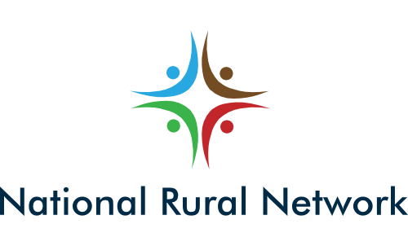
PRESS RELEASE
Immediate release:
NEW CONSORTIUM APPOINTED TO RUN
IRELAND’S NATIONAL RURAL NETWORK (NRN)
The Department of Agriculture today announced the appointment of a new consortium led by Irish Rural Link, supported by The Wheel, NUI Galway and Philip Farrelly & Co. to run Ireland’s National Rural Network (NRN). The new consortium will be responsible for facilitating all stakeholders and interested groups in achieving better outcomes across all the measures under the Rural Development Programme 2014-2020 (RDP).

The NRN is part of the implementation architecture for RDPs across the EU, and its primary aims are to increase stakeholder involvement, improve quality of implementation, inform the public and potential beneficiaries, and foster innovation.
Commenting on the announcement, Seamus Boland Chief Executive of Irish Rural Link said: “The ambition of the new consortium is to maximize the impact of the RDP by bringing it into the lives of as many people and communities as possible. We aim to transform levels of engagement with the programme, and by building participation in its implementation, and a sense of ownership of the programme amongst stakeholders, to maximise the positive impact in the lives of people and communities across rural Ireland.”
Deirdre Garvey, Chief Executive of The Wheel added: “Through decades of combined experience working with rural communities, researching rural issues, and networking with and on behalf of rural communities the members of the consortium have developed an innate understanding of the issues and pressures facing rural Ireland and the obstacles to higher participation in and knowledge of programmes designed to address these issues. We look forward to working with rural communities across Ireland to help them maximise the beneficial outcomes of the RDP. ”
Dr Maura Farrell, Director MA in Rural Sustainability at NUI Galway said The National Rural Network consortium will endeavour to create strong linkages between the administrative structures and organisations delivering Rural Development in Ireland. Through a resilient and systematic communications structure, the Network aims to increase stakeholder participation, expand the quality of rural development programmes and advance and disseminate innovative practices that can positively influence individuals and societies throughout rural Ireland.”
Also commenting on today’s announcement, agricultural consultant Philip Farrelly said: “Actions under the RDP are felt across all farms and all sectors across the broader rural community. The RDP’s funding programme provides an unmatched stimulus throughout the entire rural community, delivering income support and incentivising environmental gains to the lowest income sectors. The NRN will strive to achieve the highest participation rates and best outcomes for rural families and the environment. ”
For more information visit www.nationalruralnetwork.ie or email info@nationalruralnetwork.ie.
-ENDS-
For more information contact Seamus Boland 086-2491153 or James Claffey 087-281 9741.

Notes for the Editor:
In accordance with Article 54 of Council Regulation (EC) No 1305/2013, the aims of the National Rural Network (NRN) are to:
- Increase the involvement of stakeholders in the implementation of rural development. This will involve public authorities, economic and social partners and bodies representing civil society at national and local level.
- Improve the quality of implementation of rural development programmes
- Inform the broader public and potential beneficiaries on rural development policy and funding opportunities. This will include the sharing of information via the European Network of Rural Development and the European Innovation Partnership (EIP-Agri Service Point)
- Foster innovation in agriculture, food production, forestry and rural areas.

About the new NRN consortium

Irish Rural Link is the national network representing rural communities. Irish Rural Link represents the interests of community groups in disadvantaged and marginalised rural areas by highlighting problems, advocating appropriate policies and sharing experiences and examples of good practice. See www.irishrurallink.ie

The Wheel is a national organisation that represents and supports community, voluntary and charitable organisations in Ireland. Founded in 1999, we currently have almost 1,250 members across Ireland, reflecting the enormous scope and scale of this vibrant and diverse sector. See www.wheel.ie.

The School of Geography and Archaeology NUI, Galway through its Rural Research Cluster and the Whitaker Institute for Innovation and Societal Change is a leading body with the strongest rural development credentials. Its alumni in agriculture and rural development occupy prestigious positions throughout the sector. It has unrivalled credentials in the fields of rural research and innovation. The NUI, Galway team undertake research projects, co-ordinate innovation initiatives, and undertake monitoring and evaluation initiatives. See www.nuigalway.ie
Philip Farrelly & Co is part of the Philip Farrelly Consultancy Group and provides technical, financial and advisory services both nationally and internationally particularly in the areas of agriculture, EU policy, rural development initiatives, international and EU environmental policy and across the range of environmental media. In addition to its policy credentials the group possesses detailed knowledge and experience at the implementation and uptake of all the initiatives within the RDP. See www.pfarrelly.com​

